Q1) https://www.hackerrank.com/challenges/python-loops/problem

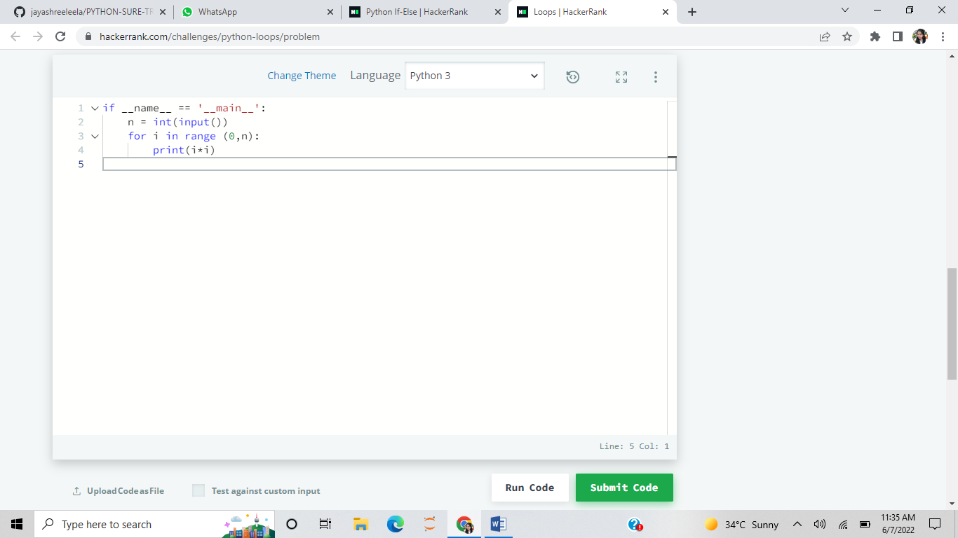

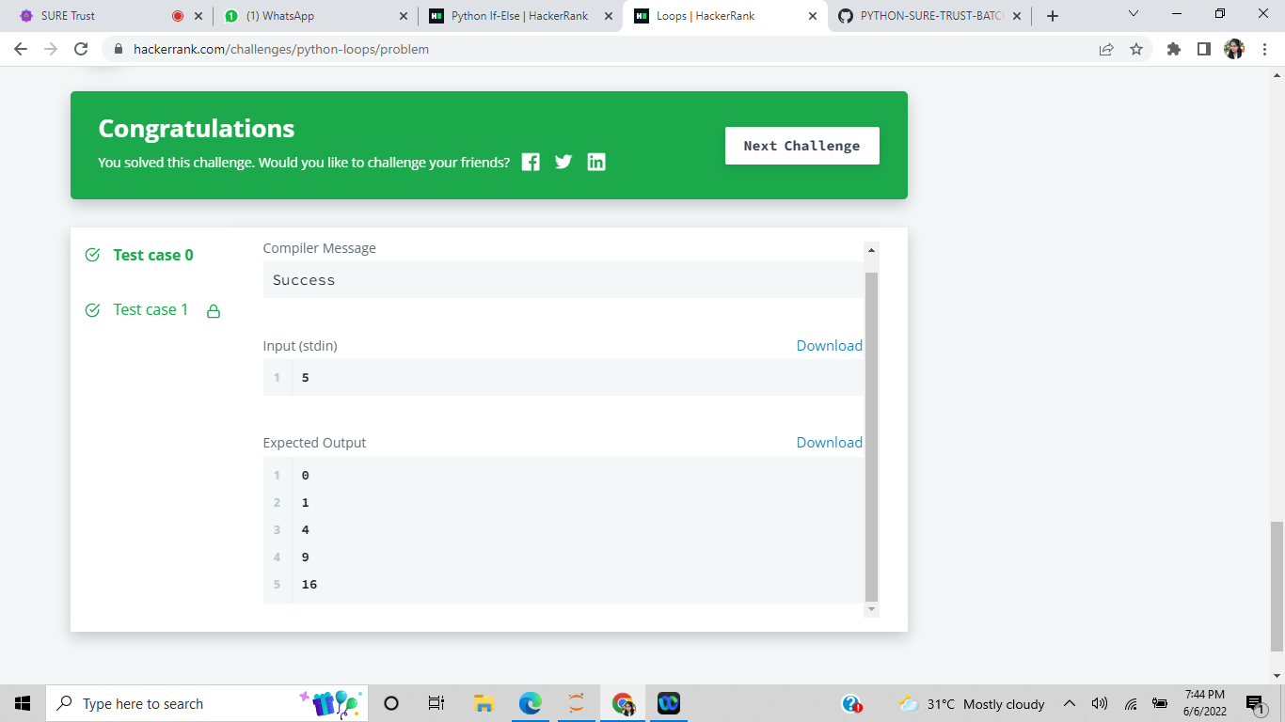

Q2) <https://www.hackerrank.com/challenges/whats-your-name/problem?isFullScreen=true>

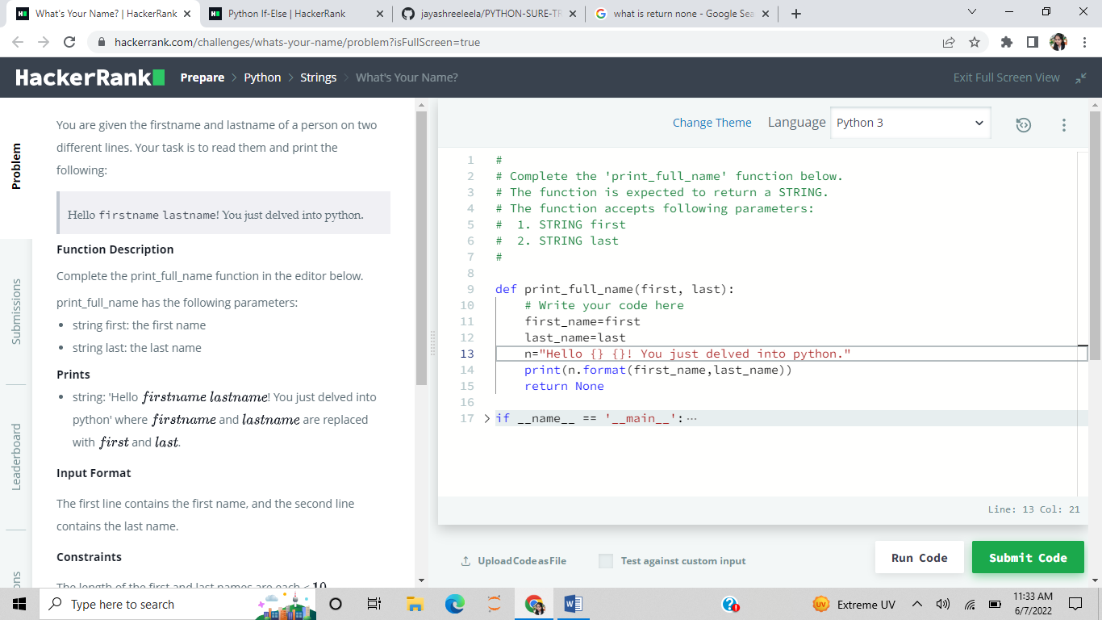

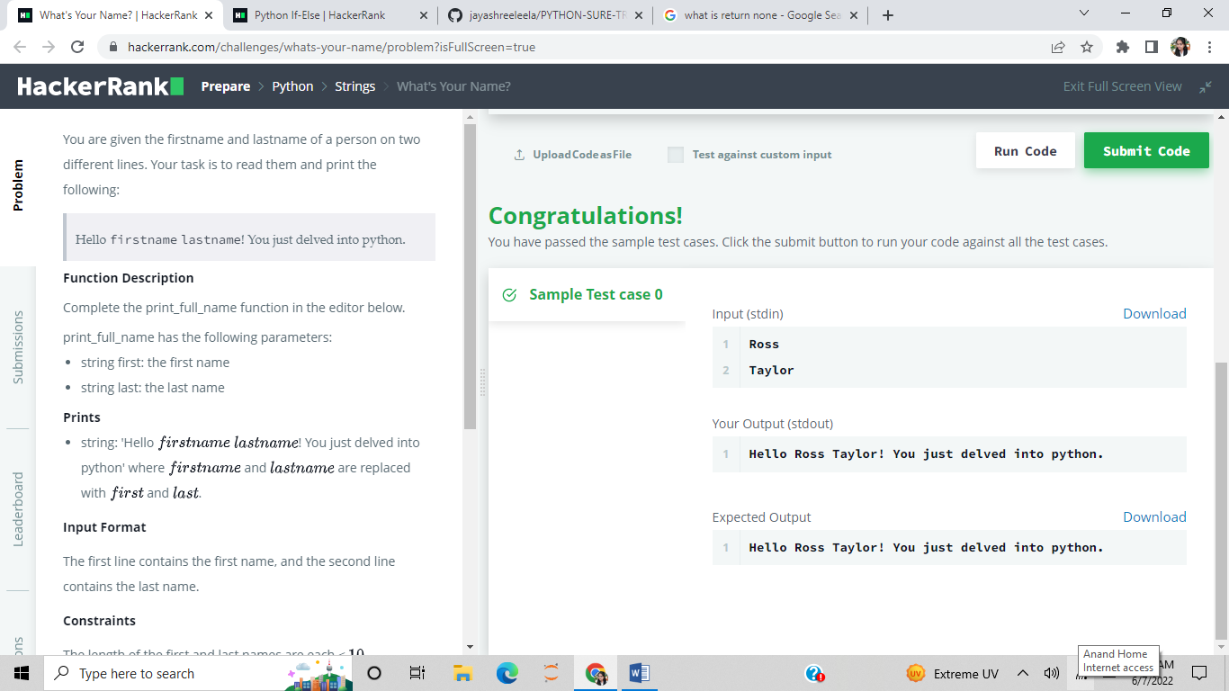

Q3) <https://www.hackerrank.com/challenges/py-if-else/problem?isFullScreen=true>

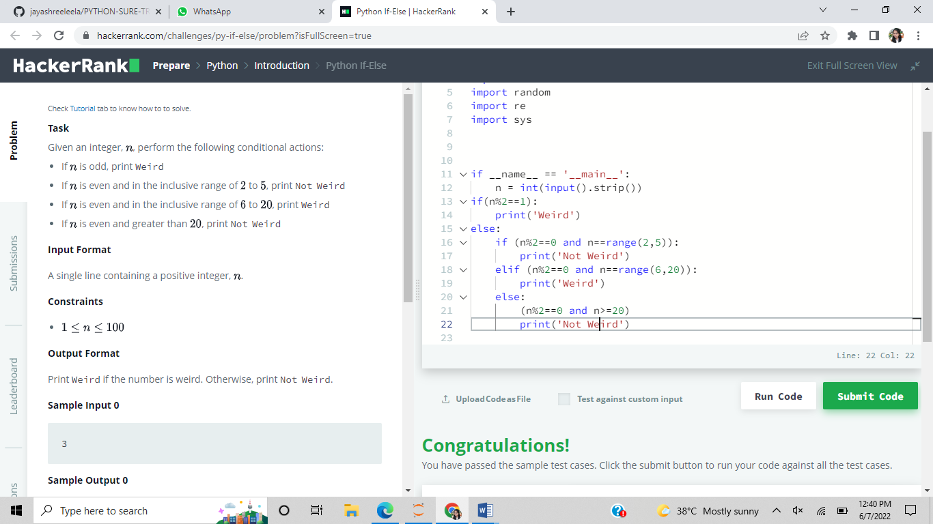

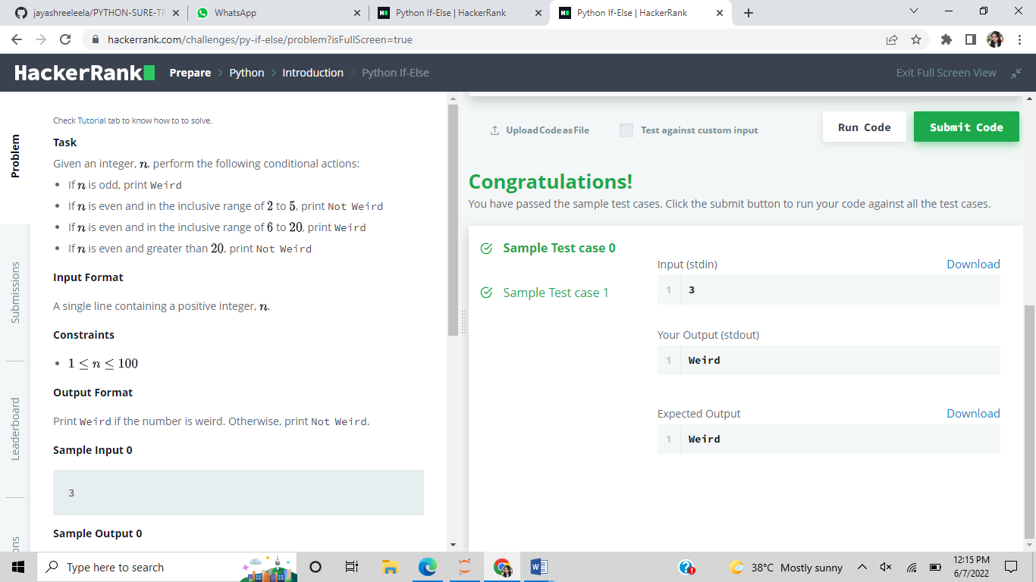

Q4) for loop

